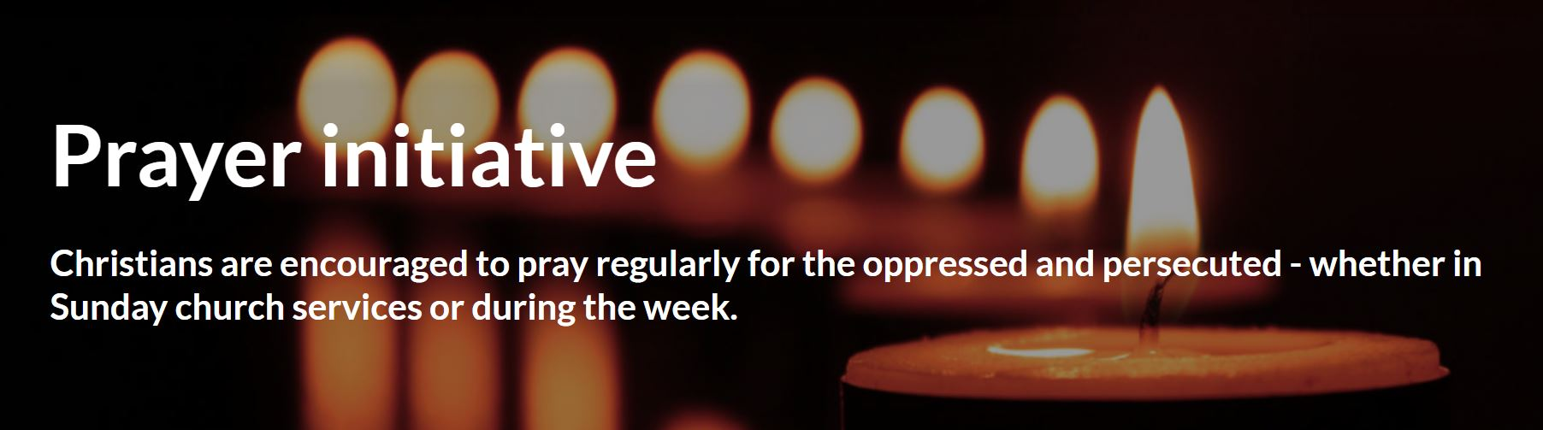
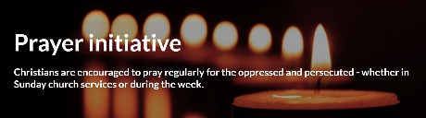

Prayer topics in May:

Sunday, May 5: IRAN
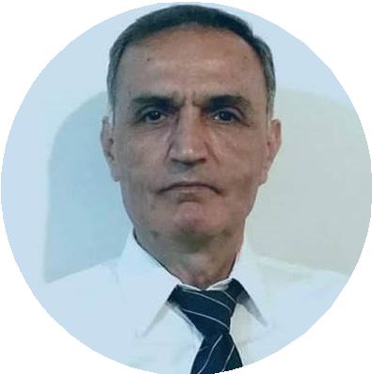
Iranian-Armenian pastor Anooshavan Avedian
(61) is currently serving a 10-year prison
sentence in Evin Prison, Tehran. He
wasarrested along with two Christian
converts when around 30 agents
raided a private Christian gathering in
Narmak, North Tehran on August 21,
2020. A request for a retrial was rejected in
August. Anooshavan presented himself to Evin Prison on September 18, 2023.
- We pray for Anooshavan to be freed, and for Christian converts in Iran to be allowed to practise their faith in peace.

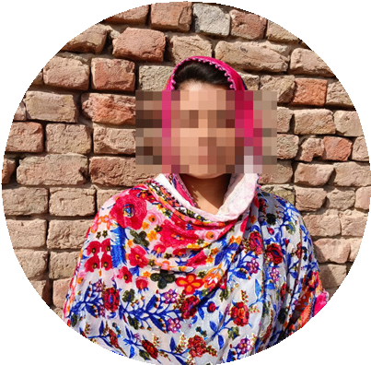
Sunday, May 12: PAKISTAN
Sadia Aslam, 17, and her elder sister
Safia, 20, were abducted by three
men while attending a party at a
school on February 24, 2024. Both
girlswere drugged and raped by the
men. The police were able to locate and
free Sadia on March 6 through sim card tracing,
but Safia’s whereabouts remain unknown.
- We give thanks for Sadia’s return, pray for Safia to be freed, and remember all victims of abduction and forced marriage in Pakistan.

Sunday, APRIL 21: SOUTH SUDAN
In August 2023, Manisha, an 11-year-old
Christian, was sold by her mother and
Hindu stepfather to human traffickers
in Delhi. Thankfully, due to the rapid
intervention of the local police, Manisha
was rescued before she could be trafficked.

Sunday, May 19: BANGLADESH
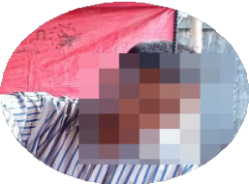
Lovelu Sadek converted to Christianity 10
years ago and became a pastor.
Because Lovelu shared his faith
openly, the family began to face
opposition. In February 2024,
Lovelu’s name was added to a list of
people accused of blasphemy by
Muslim extremists and he was jailed. Lovelu has now been bailed, but the charges against him have not been dropped.
- We pray for protection for Lovelu and all Christian converts in Bangladesh.

Sunday, MAY 26: MYANMAR
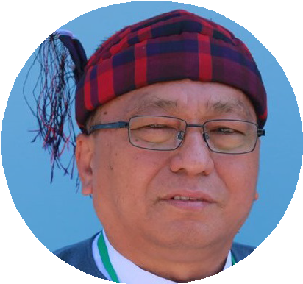
Hkalam Samson, a former Baptist leader
and human rights advocate, was
sentenced to six years in prison in
April 2023 after speaking out about
the oppression of minorities, including
Christians, in Myanmar. On April 17 this
year, he was pardoned and freed in an amnesty. However, within a matter of hours the military detained him again.
- We pray for Pastor Hkalam in prison and for protection on the Christian minority in Myanmar.

Would you like to receive regular prayer news? Sign up for our monthly newsletter here:
www.csi-int.org/get-involved/pray

